**17/10/2023**

* **DDL COMMAND:**

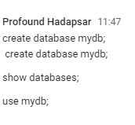

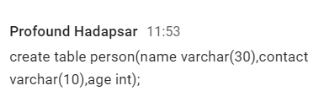

Describe tablename;/desc tablename;

**Alter command**= alter table tablename(age varchar(20)); //alter table person add column contact

varchar(10);

drop = alter table person drop column columnname;

modify= alter table person modify column gender varchar(1);

**Truncate Command**= truncate table person;

**Drop Command**=drop table person;

**Primary key**=create table person(name varchar(30) primary key,contact varchar(10),age int);

OR

create table person(name varchar(30),contact varchar(10),age int,primary key(name));

**Unique and Not null**=create table person(name varchar(30),contact varchar(10)unique,age int not null);

**Default**=alter table person add contry varchar(20) default 'India';

**Rename**  **table**= rename table person to newperson;

**Rename column**= alter table person *rename column old_name to new name;*

*OR*

alter table person change column contry country varchar(10) ;

* **DML COMMAND:**

**Insert Command=** insert into person values('Dipika','99999999',20);

Show table= Select * from person;

Insert into person column(name) values('dipti'),(‘sonal’),(‘trupti’);

Insert into person column(name,age) values('dipti',22),(‘sonal’,23),(‘trupti’,21);

**Update Command=**

updateall column=update person set contact=’5467654787’;

update particular column= update person set contact=’5467654787’ where name=’dipti’;

**Delete Command=** delete from person where country='US';

**Truncate Command**=truncate person; or truncate table person;

**Date-18/10/2023**

* **DQL Command**

Create table student(sid int primary key auto increment,sname varchar(20) not null, contact

varchar(10)unique);

insert into student values(1,’Dipti’,’23456765’);)

select sname,contact from student;

update student set course=’Java’;

select * from student where course=’c’;

**or** = select * from student where course=’c’ or course=’Java’; (we alsp use oeratror OR ||)

select * from student where course=’c’ || course=’Java’;

**and** = select * from student where sid<102 and course='java';

**Distinct**= select distinct course from student;(unique values)

**Like**= select * from student where sname like ‘s%’;

select * from student where sname like 'S%a'; (start and end)

select * from student where sname like 'S_eha';(single character)

**Between**= select * from student where sid>=102 and sid<=105;(using and)

select * from student where sid between 102 and 105;(using btween) both ans are same

using and or between

select * from student where course like 'j[a,e]va';

select * from student order by sname;

select * from student order by sname desc;

select * from student order by sname asc;

select * from student order by course,sname;

select * from student where course in ('c','Testing');

* **Aggreate Function/Scalar Function**

Create table emp(id int primary key auto increment,ename varchar(20),salary int);

Insert into emp(name,salary) values(‘xyz’,200), (‘abc’,100), (‘efg’,300);

select max(salary) from emp;

select avg(salary) from emp;

select min(salary) from emp;

select count(*) from emp;

select count(*) from emp where salary>20000;

select first(ename) from emp;

select sum(salary) from emp;

select ucase(ename) from emp

;

select lcase(ename) from emp;

select mid(ename,1,2) from emp;

select ename,round(salary) from emp;

select ename,length(ename) from emp;

* **Now() function**

select now() from emp

* **Format function**

SELECT FORMAT(123456789, '##-##-#####');

* **Grouped by**

select course,count(*) from student group by course;

alter table emp add dept varchar(20);

update emp set dept=’it’ where salary>=2000;

select dept,max(salary) from emp group by dept;

select course,count(*) from student group by course;

select dept,max(salary) from emp group by dept

select dept,max(salary) from emp group by dept having dept='IT';

select dept,max(salary) from emp group by dept having max(salary)<50000;

**Date-19/10/2023**

* **Foreign key =**

Create table course(cid int primary key auto_increment,cname varchar(20)unique,duration int not null,fee int not null);

Insert into course(cname,duration,fee)values(‘Dipti’,15,4000), (‘Trupti’,25,5000);;

Create table student(sid int primary key auto_increment,sname varchar(20) not null,contact varchar(20)unique, cid int, foreign key (cid) references course(cid));

Insert into student(sname,contact,sid)values(‘kedar’,’87654389’,2);

show create table student;

**Drop Foreign key**=alter table student drop foreign key student_ibfk_1;

* **Join Query**

Select sid,sname, cname, duration,fee from student,course where cid.student-course.cid;

Select sid,sname, cname as course, duration,fee from student s,course c where course s.cid-c.cid;

Create table fruits(fid int primary key auto_increment,fname varchar(20)not null);

Insert--------------------------||---------------------------------------------

Create table fruit_eater(id int primary key auto_increment,name varchar(20)not null,fid int, foreign key (fid) references fruits(fid);

Insert ----------------------------||----------------------------------------------

**Left join=** select * from fruits f left join fruit_eater e on f.fid=e.fid;

**Right join=** select * from fruits f right join fruit_eater e on f.fid=e.fid;

**Inner Join=** select id,name,fname from fruits f inner join fruit_eater e where f.fid=e.fid;

select id,name,fname from fruits f , fruit_eater e where f.fid=e.fid;

**Full Outer Join/Cross join =**select * from fruits,fruit_eater;

Create table emp(eid int primary key,ename varchar(20) not null,salary int,supervisor int);

Insert---------------------------------||--------------------------------------------

**Self Join=** select e1.ename,e2.supervisor from emp e1,emp e2 where e1.supervisor-e2.eid

select e1.ename ,e1.supervisor,e2.ename sipervisor_name from emp e1,emp e2

where e1.supervisor=e2.eid;

* **Set Operations**

Create table emp_india (eid int primary key,ename varchar(20) not null,salary int);

Insert into emp_india values(101,’dipti’,2000), (102,’kedar’,3000), (103,’shubham’,4000);

Create table emp_usa (eid int primary key,ename varchar(20) not null,salary int);

Insert into emp_india values(201,’d’,4000), (102,’k’,5000), (103,’shubham’,4000);

**Union=** select * from emp_india union select * from emp_us;

**Union All=** select * from emp_india union all select * from emp_us;

**Intersect=** select * from emp_india intersect select * from emp_us;

**Minus**= select * from emp_india minus select * from emp_us;

* **SQL View**

create view fruit_view as select id,name,fname from fruits f inner join fruit_eater e where f.fid=e.fid;

Select * from fruit_view;

**Date-23/10/2023**

* **Date function**

Create table person(name varchar(20),DOB date,contact varchar(20));

Insert into person values(‘Dipt’, ‘2023/04/12’,’2034565872’);

Insert into person values(‘Dipt’, ‘2023/04/12’,’2034565872’);

Insert into person values(‘Dipt’, ‘2023/04/12’,’2034565872’);

Select name,date_format(DOB,’%d-%m-%y)from person;

Select now();

Select curdate();

Select curtime();

Select name,extract(day from DOB)from person;

Select name,extract(month from DOB)from person;

Select name,extract(year from DOB)from person;

select name,date_add(DOB,Interval 1 month) from person;

select name,date_add(DOB,Interval 20 day) from person;

SELECT date_format(DOB,'%d-%b-%y %W') from person;

SELECT date_format(DOB,'%d-%b-%y %a') from person;

* **Indexse**

Create index idx_name on person(name);

Select * from idx_name;

drop index idx_name on person;;

**Unique index**

create unique index idx_name on person(name);

alter table person drop index idx_name;

**Regular Expression**

Create table employee(-----------------------------||--------------------------);

Insert into employee values(-----------------------||-----------------------);

select * from employee where first_nameregexp '^j';

select * from employee where first_nameregexp 'y$';

select * from employee where first_nameregexp 'j.hn';

select * from employee where first_nameregexp 'h';

select * from employee where first_nameregexp 'jo';

select * from employee where first_nameregexp '[mp]';

select * from employee where first_nameregexp '^j|y$';

select * from employee where first_nameregexp '^[^jr]';

select * from employee where first_nameregexp 'p*';

select * from employee where first_nameregexp 'p+';

select * from employee where first_nameregexp 'r{2,4}';

* **PL/SQL**

**Out Parameter**

**Example 1**

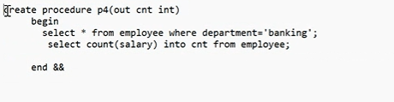

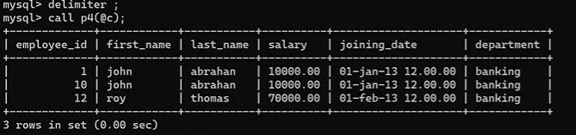



Example 2

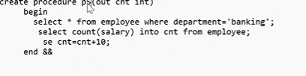

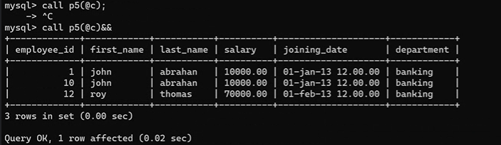

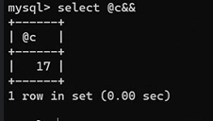

InoutParamter

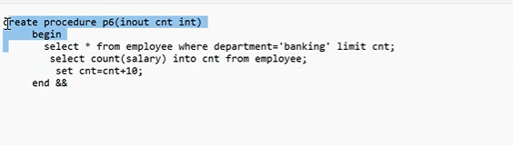

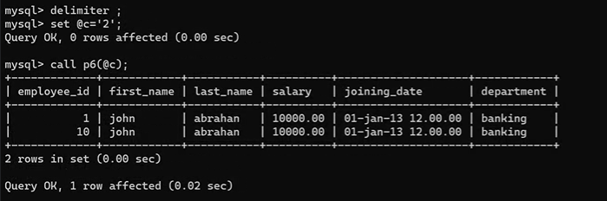

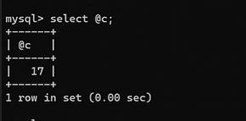

**Date 25/10/2023**

* **Combine query/complex query (remaining part)**

Select max(salary) from emp;

Select ename, salary from emp where salary=(select max(salary)from emp);

* **Transaction management**

//**By default autocommit is true**

1st Create table emp;

Select * from emp;

Set autocommit=false;

Update emp set salary=35000 where ename=’abc’;

Commit;

Rollback;

* **PL/SQL**

Stored function

delimiter &&

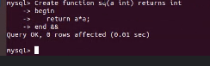

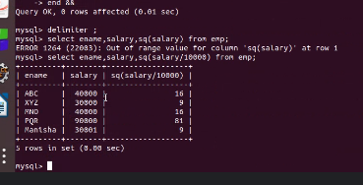

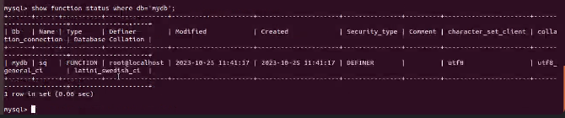

* **Triggers**

1st example

delimiter &&

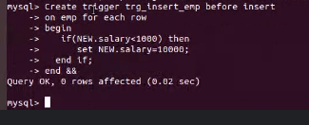

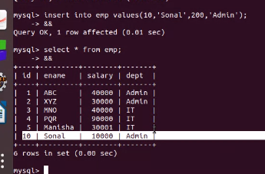

2nd example

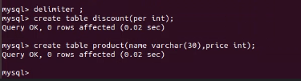

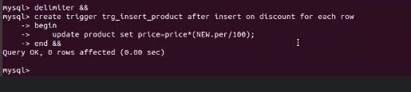

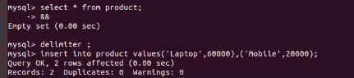

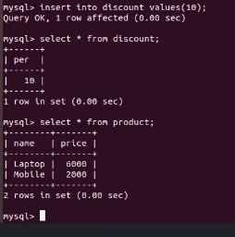

* **Cursor**

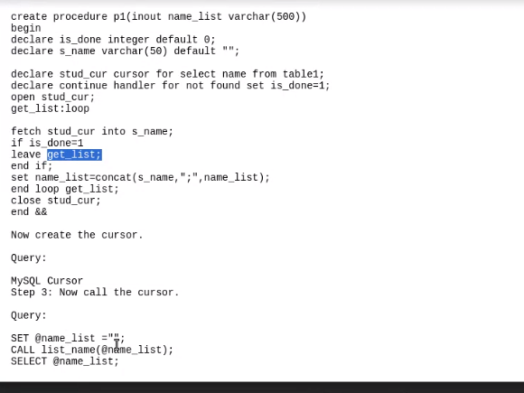

Example 1:

delimiter &&

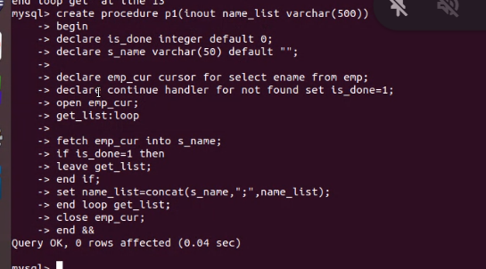

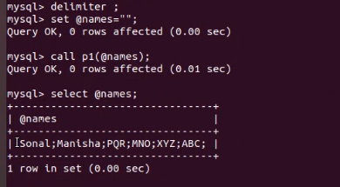

27/10/2023

Create procedure

